Document Status: Approved
Approved by: Management Representative
Released by : Mentor Labs

Revision / Document History

Version | Date | Changed by | Modifications
1.0.0 | 21/07/2025 | Routhu Rambabu | Updated Functional Requirements and Use case diagrams

List of Abbreviations
DFD Data Flow Diagram
E-R Entity Relationship
RS Requirement Specification

Table of Contents
1. Introduction 3
1.1 Purpose 3
1.2 Scope 3
1.3 Definitions, Acronyms and Abbreviations 3
1.4 References 3
1.5 Coordinators 3
2. Software Requirements 3
2.1 Operational Requirements 3
2.2 Functional Requirements 4
2.3 User Interface Requirements 7
2.4 External Interface Requirements 18
3. Project Execution Related Requirements 18
3.1 Development Environment 18
Technologies to be used for development of the Application: 18
3.2 Design requirements 18
3.3 Coding requirements 18
3.4 Error handling requirements 18
3.5 Resource Requirements 18
Technologies to be used for development of the Application: 18
3.6 Risk management 18
3.7 Training Requirements 18
4. Testing Requirements 18
5. Quality Assurance Activities 19
6. Software Acceptance Criteria 19
7. Deliverables 19
7.1 List of Deliverables 19
7.2 Delivery 19
8. Requirements Acceptance Statement 19

Introduction:

1.1 Purpose:

This project aims to create a digital solution for Sarvotham's Spine Care hospital to efficiently manage outpatient appointments and treatments. The system will automate patient registration, doctor assignments, and status tracking to replace manual record-keeping. It enables seamless coordination between front desk staff, doctors, nurses and billing departments. Patients gain online access to their medical records, test results and payment information. The platform will improve hospital operations by reducing wait times and administrative workload. Ultimately, it enhances patient care through better organization and real-time information sharing across all departments.

1.2 Scope:

The Outpatient Schedule Tracking System project is designed to transform the manual appointment and patient management processes at Sarvotham's Spine Care into a comprehensive digital solution. The system's scope encompasses all key aspects of outpatient care management, from initial patient registration through final billing, while specifically excluding inpatient services and other hospital operations. It will establish an integrated platform for scheduling appointments, tracking patient flow, managing doctor assignments, recording treatments, processing diagnostic reports, and handling billing operations. The solution focuses on creating seamless coordination between front desk staff, medical professionals, support personnel, and billing departments, while providing patients with secure access to their health information. Importantly, the project scope is carefully bounded to outpatient services only, explicitly excluding inpatient care management, pharmacy operations, inventory control, and human resources functions to maintain focus on core outpatient workflow improvements. By implementing this system, the hospital aims to significantly enhance operational efficiency, reduce administrative burdens, and improve the overall quality of patient care through digitization and process optimization.

Definitions, Acronyms and Abbreviations:
Not Applicable

References:

Coordinators:
- Routhu Rambabu

Software Requirements :

Operational Requirements:

1. Doctor
a. Manage clinic availability (days/times) with specialization-specific slots for spine care consultations.
b. Review and confirm outpatient appointment requests (accept/decline with reasons).
c. Access and update spine treatment plans, diagnostic reports (X-rays/MRIs), and prescription records during consultations.
d. Track patient progress across visits with integrated medical history and prior consultation notes.
2. Patient
a. Search for spine specialists by availability, expertise (e.g., disc herniation, scoliosis), and consultation fees.
b. Book/reschedule/cancel in-person or follow-up appointments with real-time slot validation.
c. View/upload spine-related documents (MRI reports, prescriptions) to their profile.
d. Receive notifications for appointment reminders, test results, and billing updates.
e. Access digital bills with itemized charges (consultation, tests, physiotherapy sessions).
3. Support Staff (Nurses/Lab Technicians)
a. Update pre-consultation vitals and spine-specific health metrics (e.g., pain levels, mobility range).
b. Upload and label diagnostic reports (CT scans, nerve tests) linked to patient records.
c. Assist in appointment prioritization based on urgency (e.g., acute pain cases).
4. Front Desk
a. Assign patients to spine specialists based on symptoms and doctor availability.
b. Monitor real-time appointment statuses (checked-in, in-progress, discharged).
c. Handle walk-ins by integrating them into the digital queue.
5. Billing Desk
a. Generate spine treatment-specific bills (consultation, procedures, braces/equipment).
b. Process insurance claims for spine-related treatments with coverage validation.

Functional Requirements

FIGURE 2.1 USE CASE DIAGRAM FOR OutPatient Schedule Tracking

Requirement Tag ID | RS-1-1
Source/Trigger | Patient
Description | Input | Patients can search all the doctors before login
 | Process | Explore doctors
 | Output | View details of the doctor
Validation Method | Data Updation

Requirement Tag ID | RS-1-2
Source/Trigger | Patient
Description | Input | Patient Registration
 | Process | Registration
 | Output | Patient Registration
Validation Method | Data Updation

Requirement Tag ID | RS-1-4
Source/Trigger | Patient
Description | Input | Patients Profile Updation
 | Process | Updation of Patient Profile
 | Output | Profile is changed with updates
Validation Method | Data Updation

Requirement Tag ID | RS-1-6
Source/Trigger | Doctor
Description | Input | Doctor Manage his appointments
 | Process | Update his appointments
 | Output | Change the status of his appointments
Validation Method | Data Updation

Requirement Tag ID | RS-1-3
Source/Trigger | Patient
Description | Input | Patients Login
 | Process | Explore doctors
 | Output | View All Doctors
Validation Method | Data Updation

Requirement Tag ID | RS-1-5
Source/Trigger | Doctor
Description | Input | Doctor Login & view all appointments
 | Process | View All Appointments
 | Output | Retrieve All Appointments
Validation Method | Data Updation

Requirement Tag ID | RS-1-8
Source/Trigger | Front Desk
Description | Input |  | Login
 | Process |  | View All Appointments & Patients
 | Output |  | Retrieve All Appointments
Validation Method | Data Updation

Requirement Tag ID | RS-1-9
Source/Trigger | Front Desk
Description | Input | New Registration
 | Process | Adds New Patient
 | Output | Create New Patient
Validation Method | Data Updation

Requirement Tag ID | RS-1-10
Source/Trigger | Front Desk
Description | Input | Login & Manage Patient Appointments
 | Process | View All Appointments
 | Output | Retrieve All Appointments
Validation Method | Data Updation

Requirement Tag ID | RS-1-7
Source/Trigger | Doctor
Description | Input | Doctor Profile Updation
 | Process | Updation of Doctor Profile
 | Output | Profile is changed with updates
Validation Method | Data Updation

Requirement Tag ID | RS-1-11
Source/Trigger | Support Staff
Description | Input | Login And Manage Doctor Consultation Fees
 | Process | Manage Consultation Fees
 | Output | Update the Fees
Validation Method | Data Updation

Requirement Tag ID | RS-1-12
Source/Trigger | Support Staff
Description | Input | Updates Patient Health Records
 | Process | Manage Health Records
 | Output | Update the Records
Validation Method | Data Updation

Requirement Tag ID | RS-1-13
Source/Trigger | Billing Desk
Description | Input | Login & Generate Bills based on Doctor Prescription
 | Process | Generate Bills
 | Output | Creating the bills
Validation Method | Data Updation

User Interface Requirements
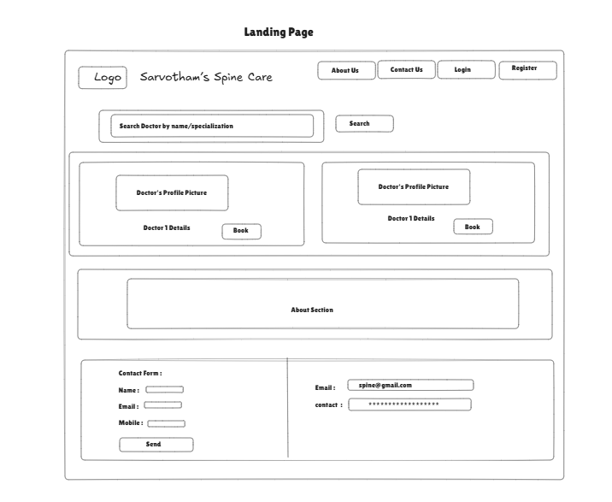
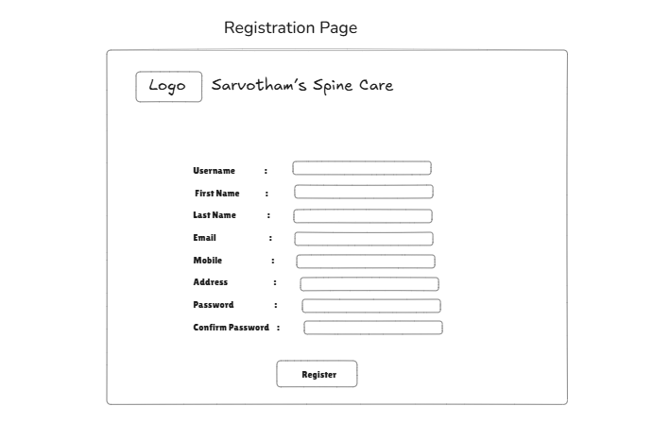

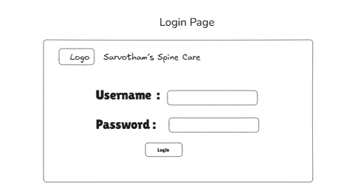

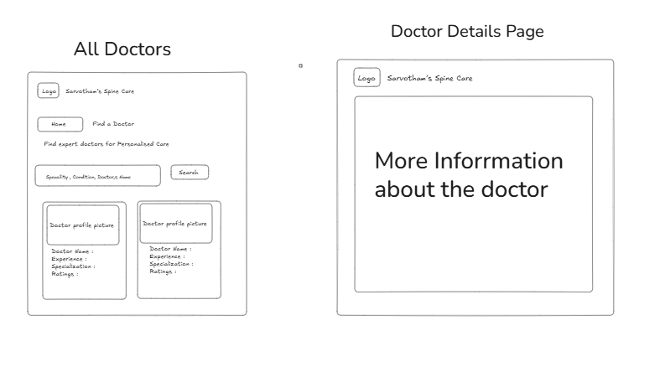

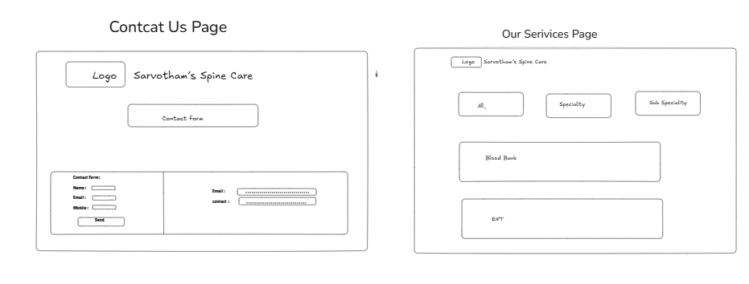

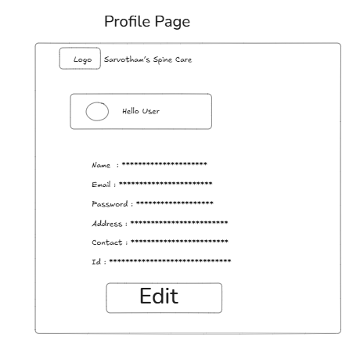

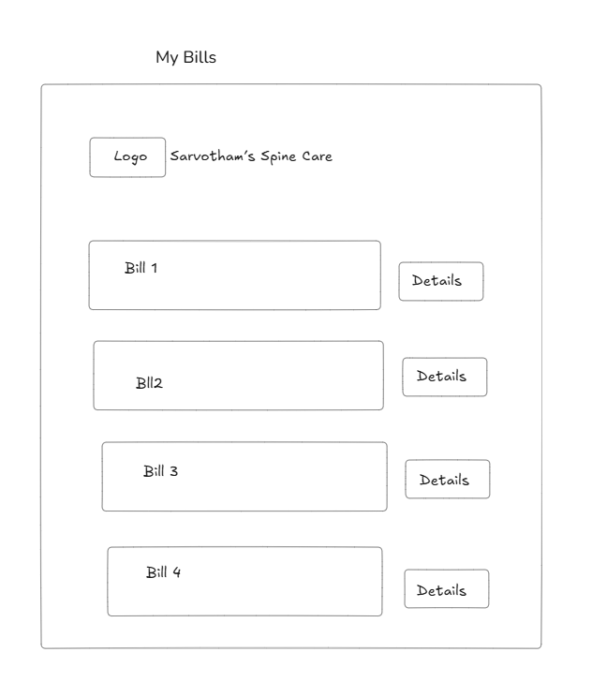
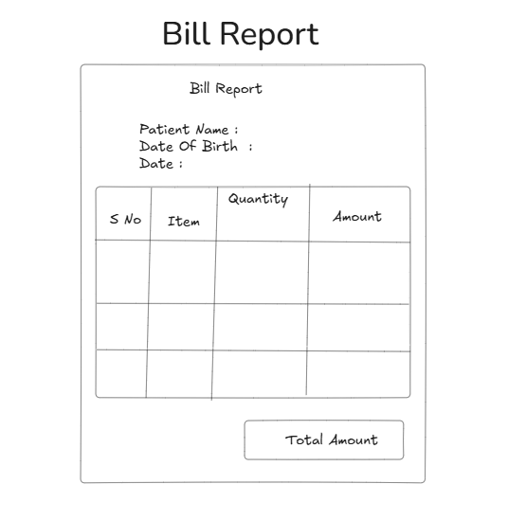

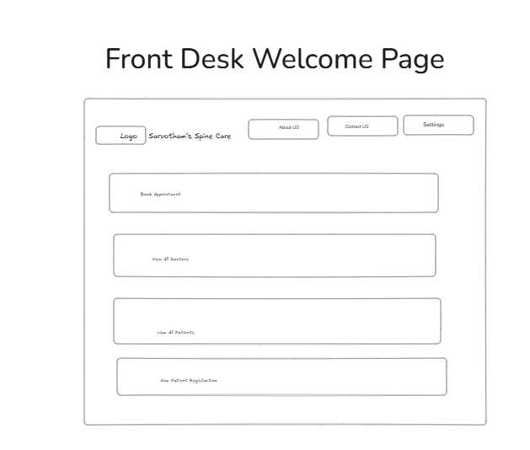

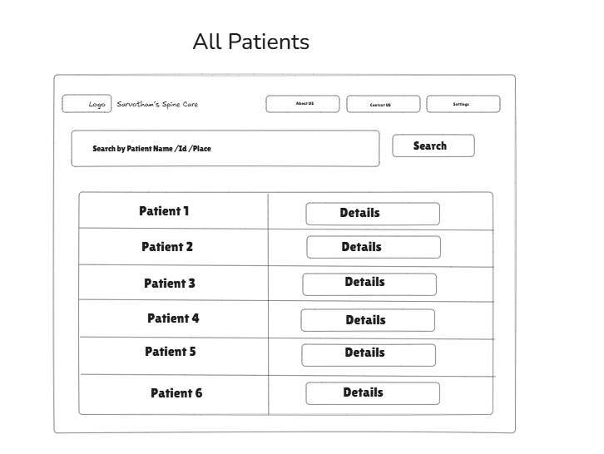

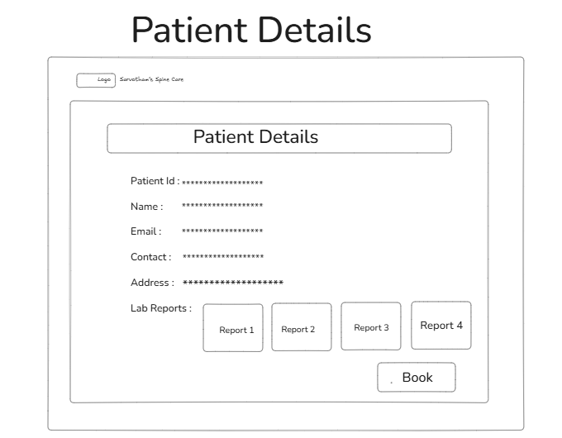
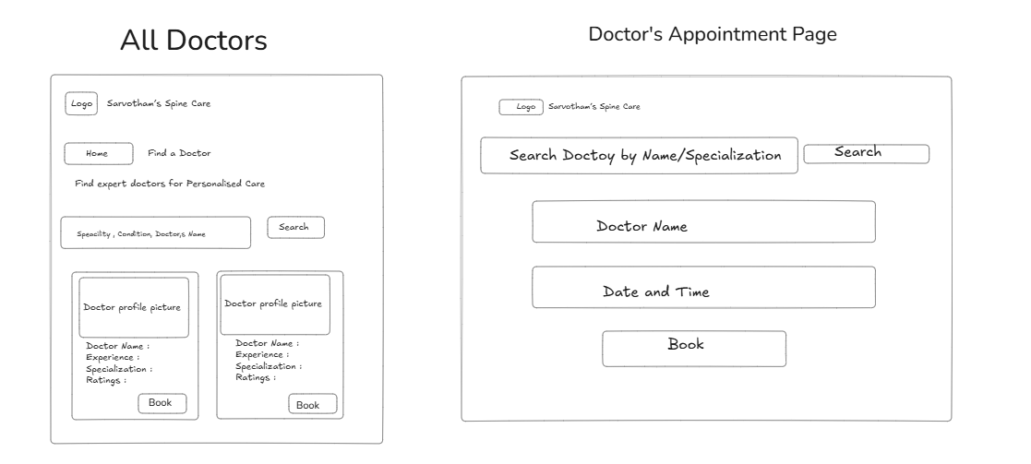
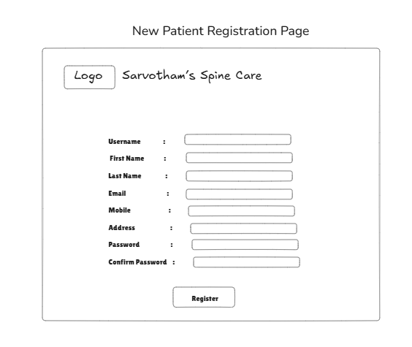

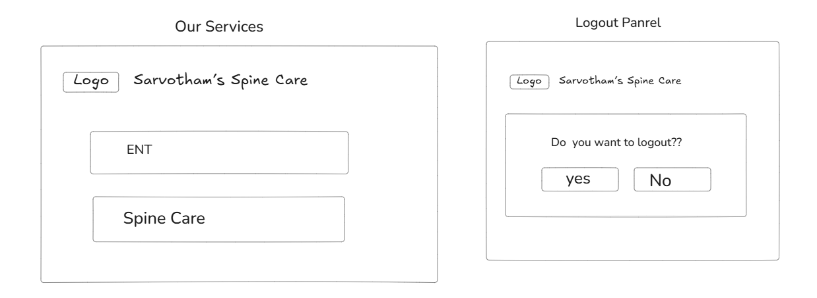
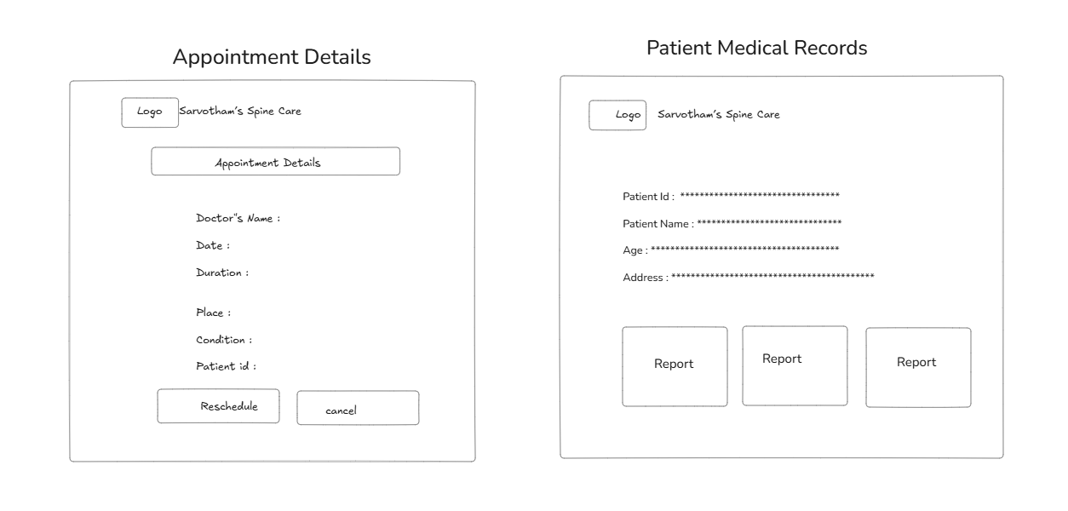
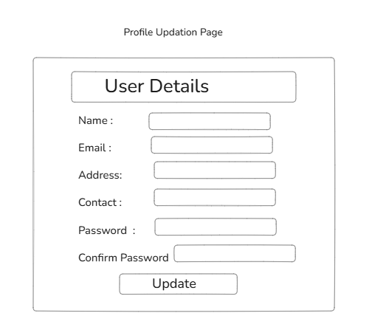

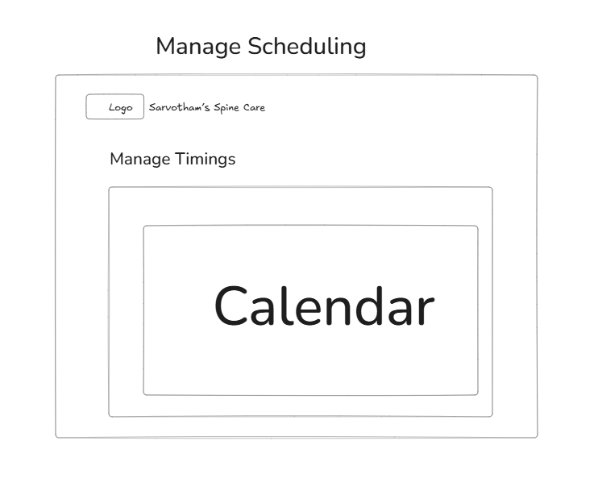

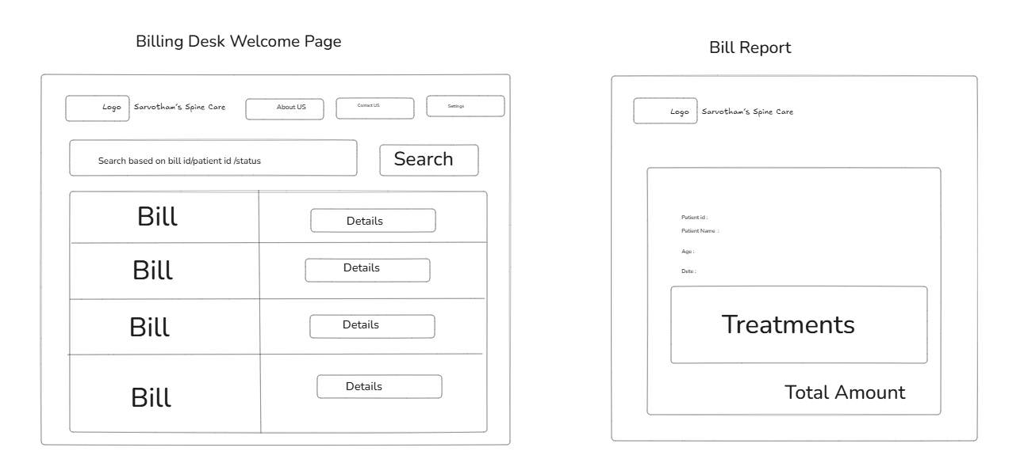
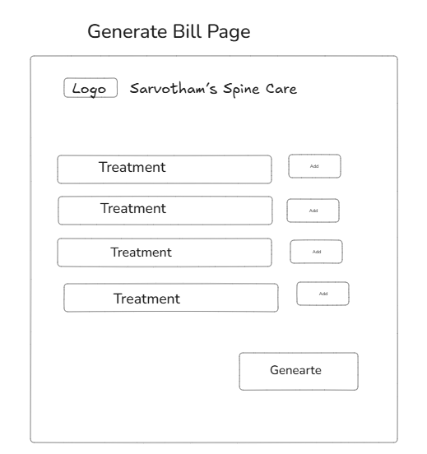

External Interface Requirements:
NA

Project Execution Related Requirements

Development Environment

Technologies to be used for development of the Application:
- Frontend:
React.js for build of dynamic, responsive, and user-friendly web portals accessible by Admin patients, hospital , insurers

- Backend:
Java Spring Boot framework using microservices architecture to ensure modularity, scalability, and ease of maintenance.

- Database:
MongoDB for flexible, scalable document-based storage to handle complex, nested data like patient records, claims details, and document attachments efficiently.

- Github copilot for developing the microservices
Software tools that can be used for development:
- Spring Tool Suite
- Enterprise Architecture/ EdrawMax
- Visual studio code
- MongoDB

Design requirements

Not applicable.

Coding requirements: Java, JavaScript
Since the entire application is being coded in Java Spring Boot, all the coding standards required by Java are applicable here.

Error handling requirements
Not applicable.

Resource Requirements

Technologies to be used for development of the Application:
- Java (JDK 17)
- MongoDB
- VS Code

Risk management
Not applicable.

3.7 Training Requirements

Since the application being developed is greatly dependent on user interaction, the end user should be comfortable with the GUI.
- End users should be given a walkthrough of the working of the entire application along Training should be provided with respect to efficient GUI usage. 3.7

4. Testing Requirements
The testing phase shall include unit testing to validate each individual module of the system,
Integration testing to check if the system works according to customer requirements after modules’
integration. This is supported by regression testing for efficient results.
The testing is to be carried out manually following both black box testing as well as white box testing
to understand the system functionality better.\

5. Quality Assurance Activities

Not applicable.

6. Software Acceptance Criteria: User Acceptance Testing (UAT) is the sole criterion for software acceptance. The application will be accepted upon successful completion of UAT, which includes thorough end-to-end testing of all functionalities and formal stakeholder approval confirming that all specified requirements are met.

7. Deliverables

7.1 List of Deliverables
Not applicable

7.2 Delivery
Not Applicable

8. Requirements Acceptance Statement: The software will be accepted when:
- All functional requirements are fully implemented and pass all testing phases.
- The system meets defined stability and performance standards.

